Machine Learning for Social Data Science
Problem Set 2
(1,500 words)

Introduction
The UK is one of the most regionally unequal countries in the OECD (McCann, 2016, 2020), with significant disparities between London and the South East and much of the rest of the country in productivity, infrastructure, and transport (Davenport and Zaranko, 2020; Fai and Tomlinson, 2023). These inequalities are reflected in social outcomes: life expectancy in Blackpool and Middlesbrough is nearly a decade lower than in parts of Surrey (ONS, 2024). Such gaps reflect ‘left-behind’ communities shaped by deindustrialisation, austerity, and perceived political neglect (Gray and Barford, 2018; Hooper, 2023), contributing to the declining trust in the state’s capacity to deliver outside traditional centres of power. Against this backdrop, Levelling Up emerged as both a corrective policy intervention and a visible sign of renewed state attention to ‘left-behind' communities.

This essay builds on my undergraduate dissertation, which explored the impact of Levelling Up funding on turnout and Conservative vote share in the 2024 General Election through a clientelist framework. It found that constituencies lost or newly won by the Conservatives in 2019 were more likely to receive funding than non-Conservative or held seats (Appendix A). On average, each £10 million allocated was associated with a 0.71% fall in turnout and 0.5% decline in Conservative vote share. However, the effects of different types of projects remain unclear. Evidence from the US suggests that every 1% increase in federal funding increases incumbents' vote share by 1.8% in closely contested districts (Kriner and Reeves, 2012, p. 359), particularly when directed towards infrastructure and public services (Hersh, 2015).

To address this gap, this essay applies a topic model to structured text data to generate project labels. The structure of this essay is as follows: a data and methods section, followed by findings, and finally, a conclusion.

Data and Methods
To generate these labels, topic modelling is used, an unsupervised machine learning method that identifies latent themes in text. This essay uses BERTopic, which improves on traditional ‘bag-of-words’ approaches by combining embeddings with clustering. First, documents are cleaned and transformed into embeddings to capture semantic meaning. UMAP then reduces dimensionality while preserving global and local structure, outperforming T-SNE and PCA in maintaining meaningful relationships. HDBSCAN clusters documents into topics, allowing flexible, noise-aware groupings without requiring a pre-specified number of clusters, unlike K-Means.

The text is then vectorised, converting text into numerical representations based on word frequencies, and then applies c-TF-IDF to identify words specific to each topic by weighting terms according to their importance within clusters. Representation modelling refines topic labels by using the embedding model to select keywords that are both distinctive to the topic and semantically coherent. Finally, BERTopic integrates these steps, producing coherent, interpretable topics that generally outperform other unsupervised topic modelling techniques.

Due to limited existing research, there is no comprehensive public dataset on Levelling Up projects; therefore, this essay uses data collected from my undergraduate dissertation. Projects were initially assigned labels based on their stated purpose during the original data collection; however, the reliability of these labels is limited: categories evolved over time, and earlier entries were not systematically revised to reflect newly introduced labels, leading to potential inconsistencies.

The text corpus comprises individual project documents compiled from a variety of sources, including local media reports, government publications, and social media posts. The documents establish the project’s purpose, location, and completion status. There are 338 projects from the Community Ownership Fund (COF); other funding streams, such as the Levelling Up Fund, Long Term Plan for Towns, and the Towns Fund, have been excluded due to time constraints and collection challenges.

This essay addresses a single research question:
- Can BERTopic be used to generate meaningful and coherent labels for Levelling Up projects?

The unit of analysis and observation is individual projects. Internal validity is strengthened by using systematic text cleaning, embeddings, UMAP for dimensionality reduction, and HDBSCAN clustering, which come together to minimise noise and improve the consistency and coherence of the topic labels. External validity is limited, as the results are specific to COF projects and may not be generalisable to other funding streams or redistributive policies. Ethical concerns are minimal: all data collected is publicly available, and the risk of harm to projects or communities is negligible. To ensure research integrity, a GitHub repository link is provided (Appendix B).

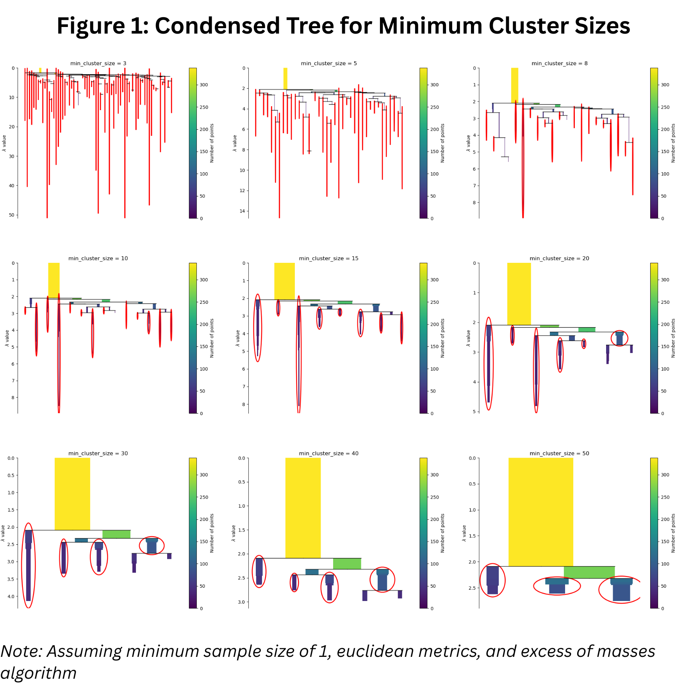

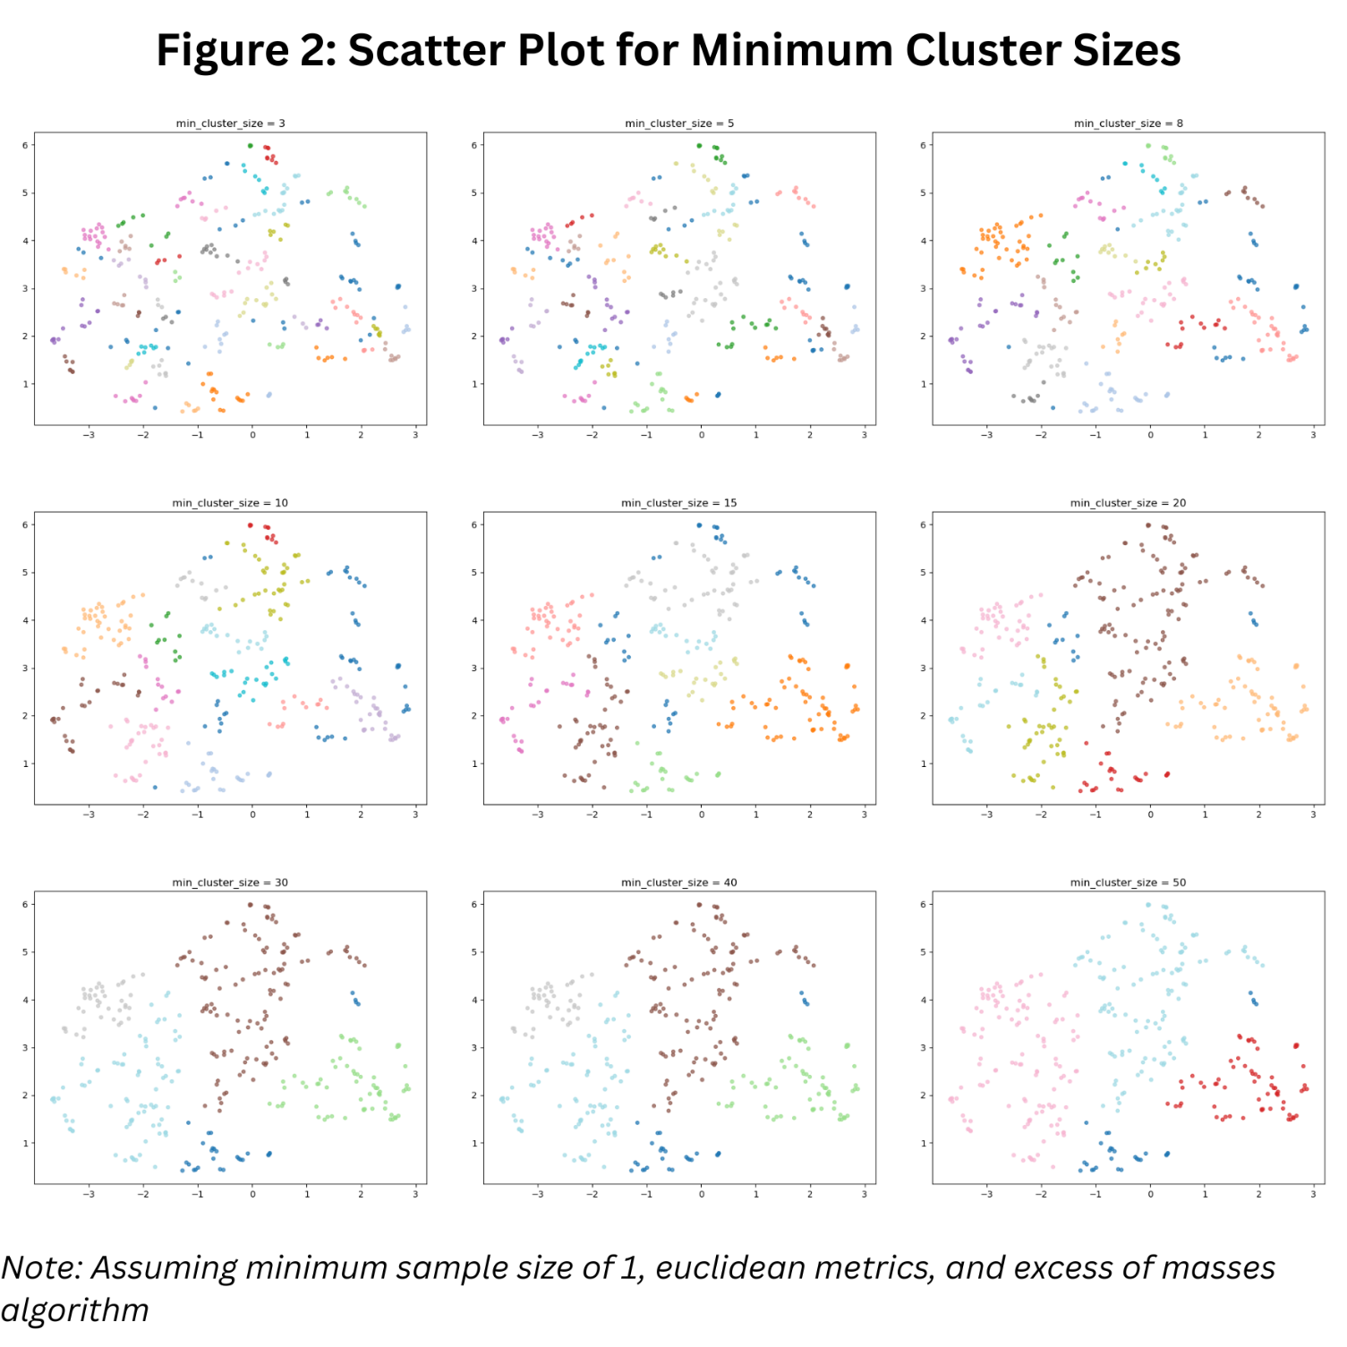

Findings

Conclusion

References

Appendices
Appendix A – Findings
Appendix B – GitHub Repository Link
Appendix C – Google Antigravity AI Agent Chat History

